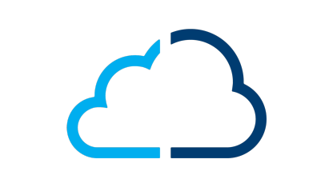

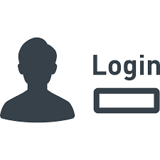

OASYS^

(1)

Login Credentials

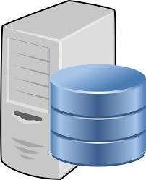

(5)

Send Token to Access APIs

Exchange SAML Packet

(4)

Send SAML Token

(3)

SAML Packet Generator (App)

Connect to ADFS 3.0

(2)

**ADFS 3.0**